Angular Framework
Angular frameworks is used to develop single page applications using two main languages Typescript & HTML.
Typescript: It is a superset of javascript
Pre-requisites for Angular
- HTML
- Javascript
- CSS
Software’s required for Angular
- Visual Studio Code: https://code.visualstudio.com/
- Node.js: https://nodejs.org/en/download/
- Angular cli: you can download this using npm command which comes from node.js
Once you install node.js you can verify node & npm versions
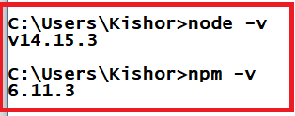

Angular CLI: It is a command line interface, which is a toolkit to develop & build the angular application, it provides lots of features
- Auto-compilation features
- Auto-reload features
- Creating project
- Hosting project
- Generating some features in the project easier way
- Server

How to install angular-cli
npm install -g @angular/cli

-g means global installation, means you can use angular commands from any location
You can verify angular/cli installation using ng –version

How to develop angular applications
You need to use ng new app-name to create the new project
Basics of HTML, CSS & Javascript
HTML: It is for displaying the content
CSS: It is for styling the content
Javascript: It is to access HTML & CSS at runtime to add dynamic feature to the content apart from performing validations.
Different types of heading in html
We have 6 different types of headings
h1, h2, h3, h4, h5, h6
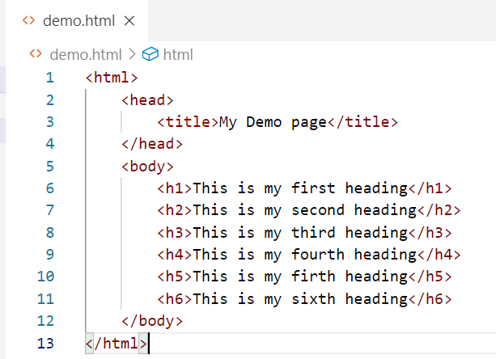

CSS: It is used to style the HTML elements/tags, there are 3 types of css selectors you can apply
- Tag selector
- Class selector
- Id selector
How to apply CSS to the HTML
We have 3 different ways to add the CSS
- External CSS
- Internal CSS
- Inline CSS

Demo.html
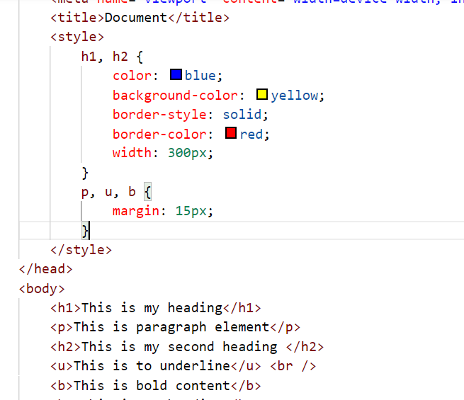

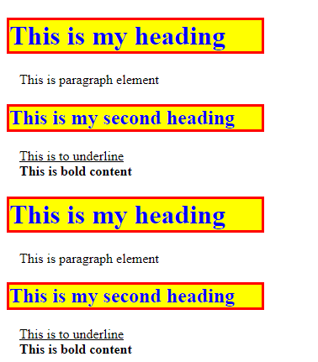
x

Javascript
It is used to access HTML elements at runtime and you can write, read or update the HTML element.
- You can also do client-side validations using Javascript
- You can create variables & functions
- You can write conditional statements (if, else, switch)
- You can write looping constructs (for, while, do-while)
- You can handle events in Javascript
  - Onclick
  - Onmouseover
  - Onmouseout
  - Onsubmit
  - Onkeyup
  - Onkeydown

These events can be handled to perform some task i.e., calling the function when such event occurs.
demo.html
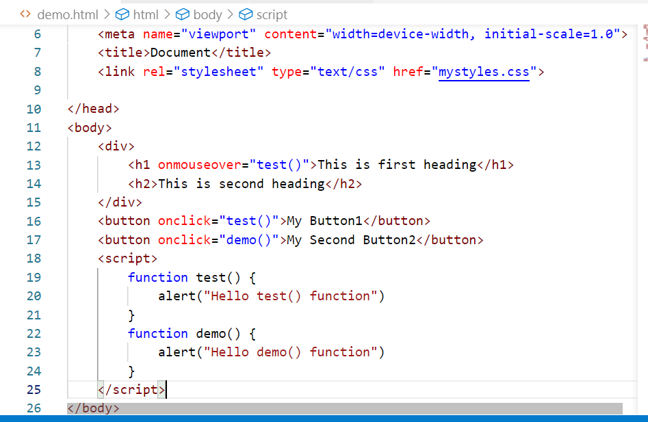
Output:
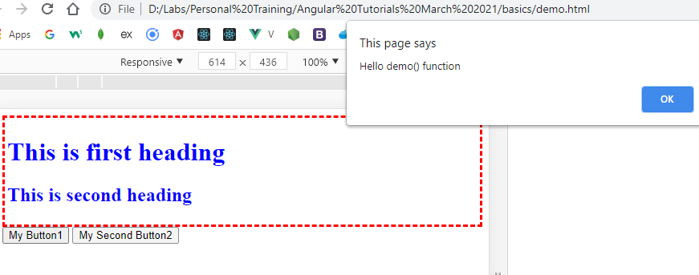

In Javascript you can pass event object, using that you can recognize the source of the event.
Ex: onclick = “fun(event)”
But your function needs to take the parameter.
Recognizing the element that generated the event
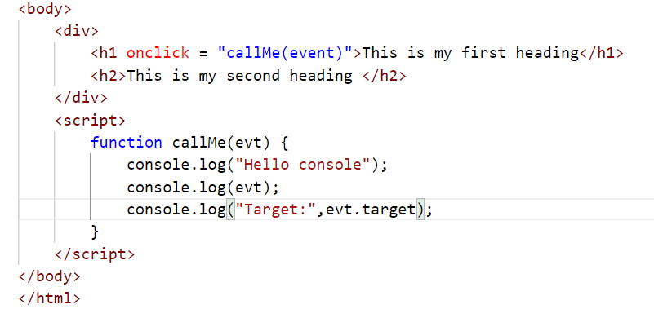
Output:
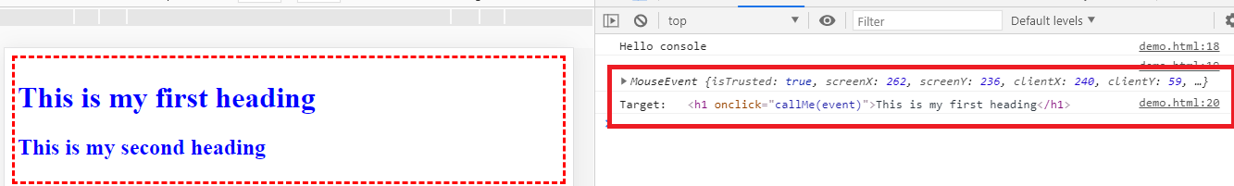

You can access element attributes also like src attribute of the <img>, style attributes of the element and so on.
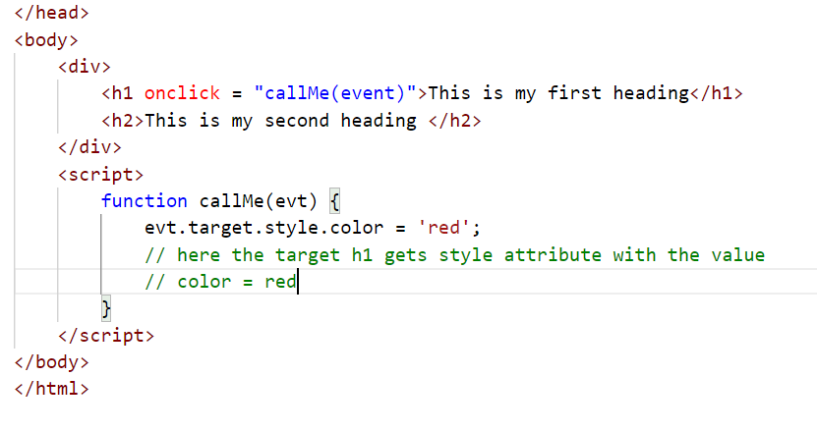
Output:
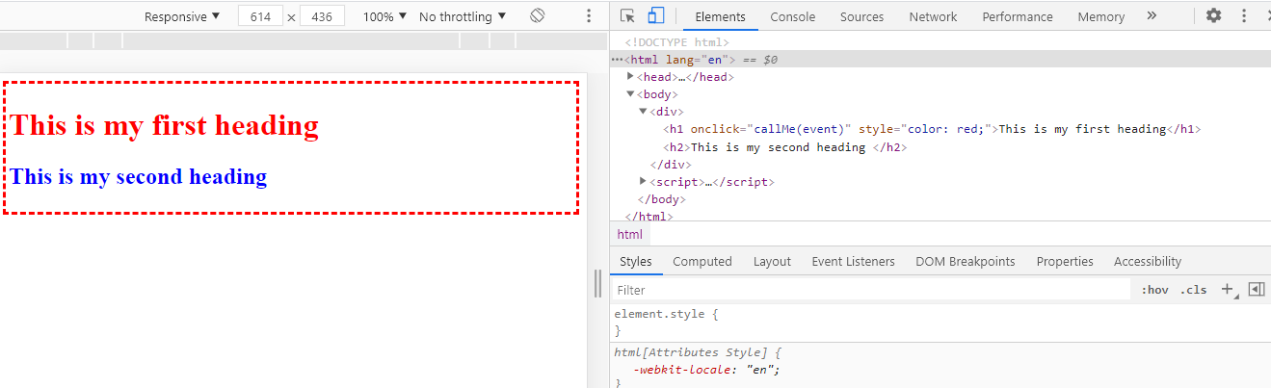

By this example you can also assume that you can modify HTML elements at runtime, you can change the image width/height by clicking on the images.
Adding external script
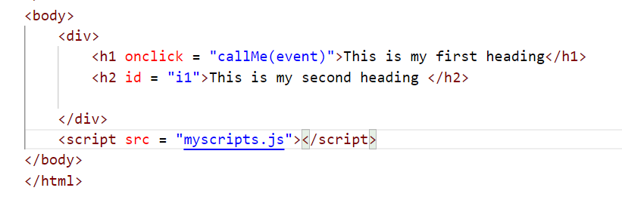

myscripts.js
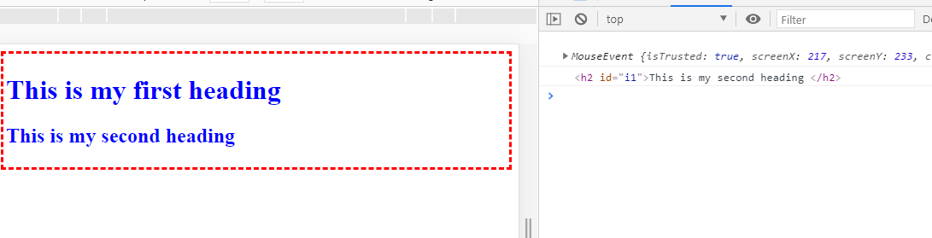

Changing the images based on the click events
demo.html
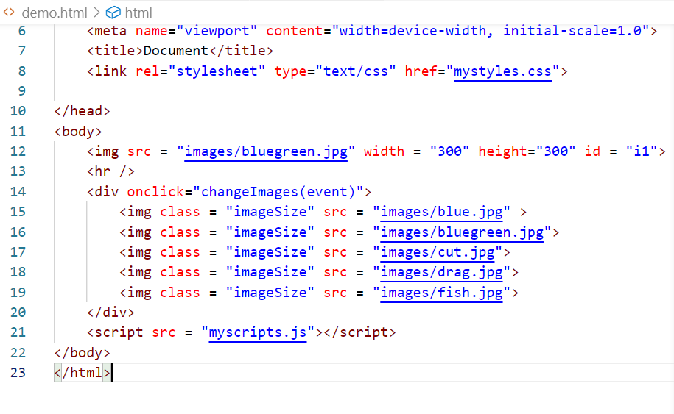
myscripts.js
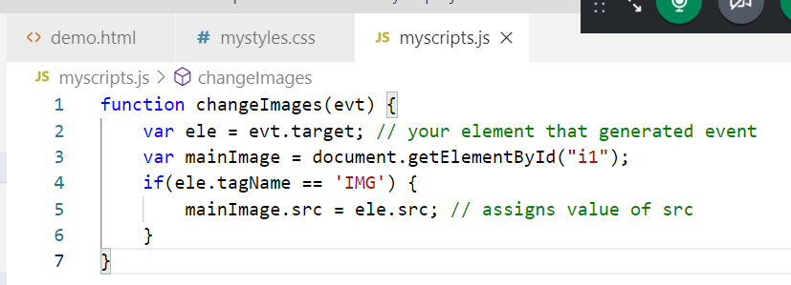
mystyles.css
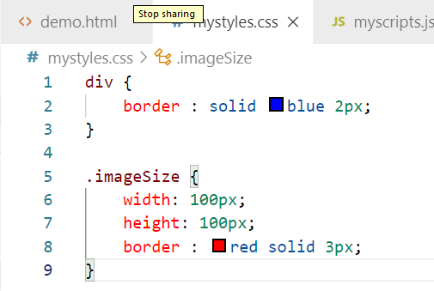

Output:
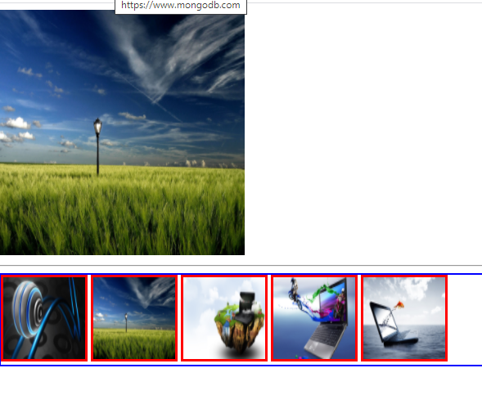

ES6 features
This is the standard for javascript this simplifies writing javascript code, it has provided lot of features like
- Keywords such as let, const, class, costructors, super, extends
- Template Strings
- Arrow functions
- Rest operator.
let & const keywords: They are used to create block scoped variables, so that you can’t use them outside the specific scope.
The ‘let’ variable can be modified but ‘const’ keyword can’t be modified.
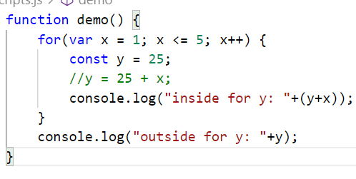
Output:
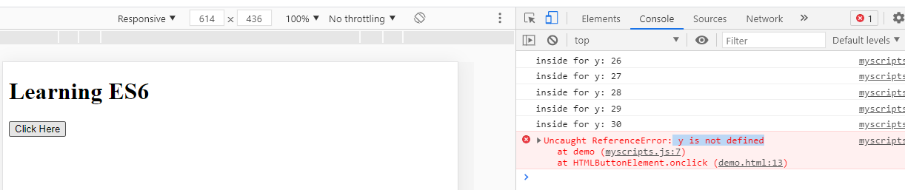

The keywords like class
In ES6 the classes and functions belonging to the objects are created as below:-
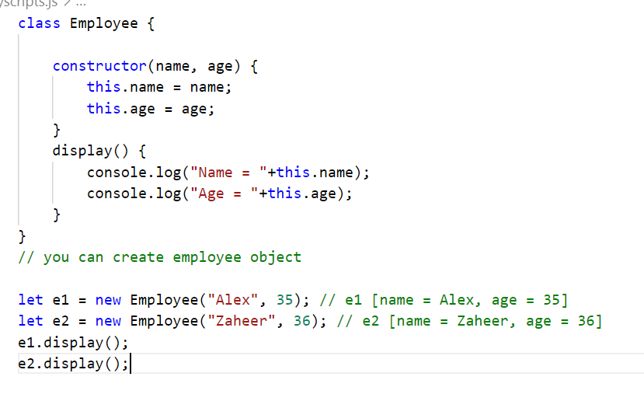
class Employee {

constructor(name, age) {
this.name = name;
this.age = age;
}
display() {
console.log("Name = "+this.name);
console.log("Age = "+this.age);
}
}
// you can create employee object

let e1 = new Employee("Alex", 35); // e1 [name = Alex, age = 35]
let e2 = new Employee("Zaheer", 36); // e2 [name = Zaheer, age = 36]
e1.display();
e2.display();

Before ES6 it was created as below:
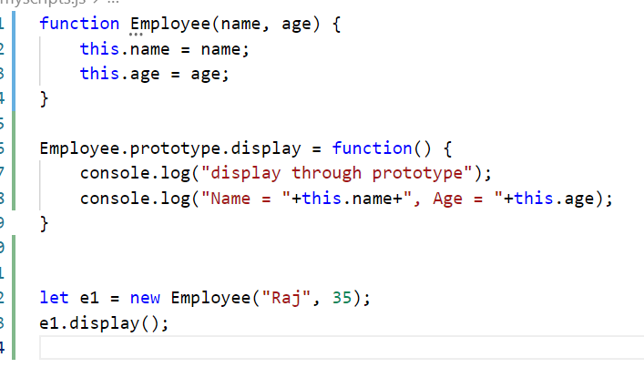

Arrow functions:
It simplifies writing anonymous function in javascript.
- Arrow function with braces is used when you have multiple statements
() => { statements}
- Arrow function without braces is used when you have single statements
() => statement;
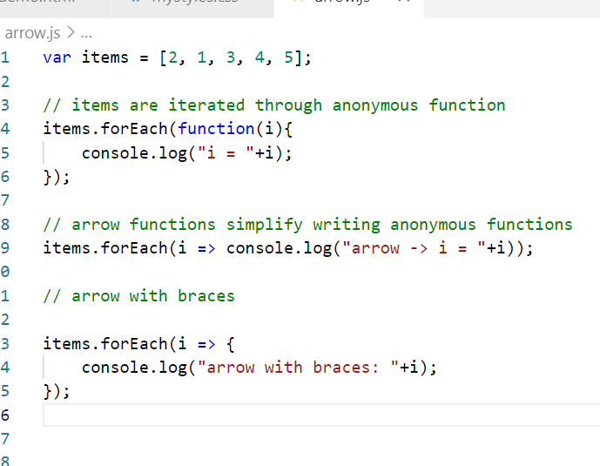
Output:
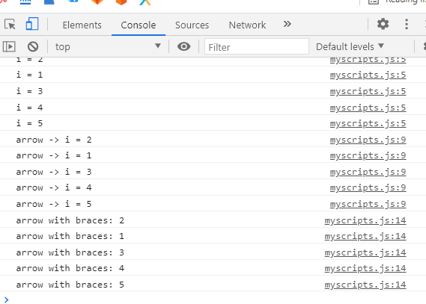

Template Strings: it avoids breaking the string into multiple string when you want to concatenate.
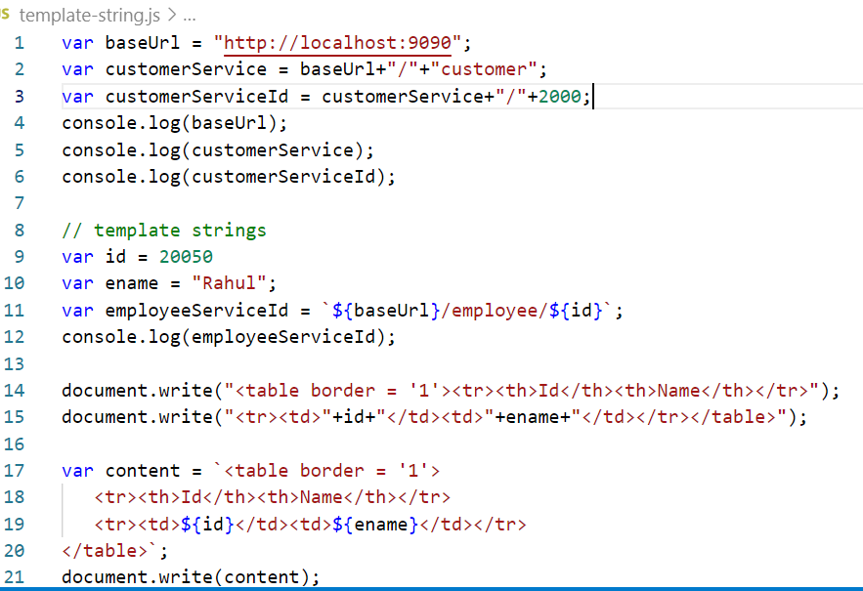
Output:
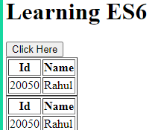

Typescript:
It is a super set of javascript, it adds types to the javascript, usually browsers don’t understand typescript, but it will be converted to javascript either by using some compiler or some frameworks like angular.

tsdemo.ts
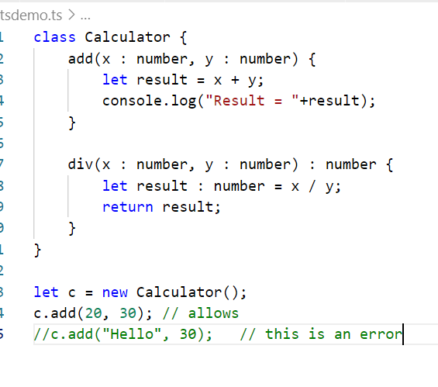

Angular Framework
It is used to develop single page applications using HTML & Typescript, angular uses components to build the User interface.
Components: These are user interfaces which can be independently developed and can be reused in other components.
Google has provided angular-cli to quickly develop & build angular applications
Angular CLI does following things
- Creates a ready to run angular project
- Configures the compiler for your project so that developer need not to compile, as it will be auto-compiled
- Configures the lite-server which can run your project
- Auto-reload feature to see the changes while developing the project
- Lot of commands to quickly create certain angular elements
Installing angular-cli
npm install -g @angular/cli
You will get ‘ng’ which means Angular once you install @angular/cli, using ng you can create angular project with the command
ng new project-name
You need to take your terminal inside the project
cd project-name
To launch the project / run the project
ng serve
(or)
ng serve -o
(or)
ng serve --port=4201

Every angular project will have some common content that can be changed.
In angular the only file which will be loaded is index.html which will have one root component.
Root Component: It is the main component which can have any number of nested components or child components, this root component is AppComponent whose content will be app/app.component.html, the tag name for the root component is <app-root>.

Creating our own component
- You must have a class with @Component decorator, which will give us selector, templateUrl & stylesUrl
- You must mention the component in the AppModule
  - AppModule represents your whole application, this will have all the components declarations
  - AppModule will have everything you create in your application, it could be router, pipes, services, forms
Things that will be mentioned in AppModule
@NgModule is the decorator to create the module, in your application you must have one module that acts as the root module

@Component({
selector : “app-emp”,
templateUrl : “./emp.component.html”
})
Export class EmployeeComponent {
name = “Alex”;
age = 36;
}
Note: You don’t have to create components manually as Angular provides a command called
ng generate component component-name
(or)
ng g c component-name
If you use this command angular creates ts, html, css, spec.ts and also component will be mentioned in the AppModule

Manually creating the components
Create employee folder and inside that create employee.component.ts & employee.component.html
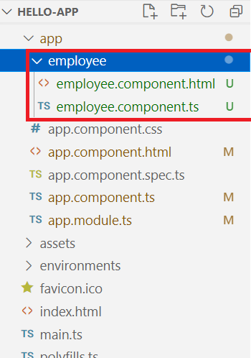

employee.component.ts
import { Component } from '@angular/core';

@Component({
selector : "app-employee",
templateUrl : "./employee.component.html"
})
export class EmployeeComponent {
name = "Alexandar";
age = 36;
}

employee.component.html
<div>
<h3>This is Employee Component</h3>
<h4>Hello {{name}} your age is {{age}}</h4>
</div>

Configure the component in the AppModule
import { BrowserModule } from '@angular/platform-browser';
import { NgModule } from '@angular/core';

import { AppComponent } from './app.component';
import { EmployeeComponent } from './employee/employee.component'

@NgModule({
declarations: [
AppComponent, EmployeeComponent
],
imports: [
BrowserModule
],
providers: [],
bootstrap: [AppComponent]
})
export class AppModule { }

Add the employee component in the root component
<div>
<h1>Welcome to Angular Learning</h1>
<h2>{{title}}</h2>

<app-employee></app-employee>

</div>

Output:

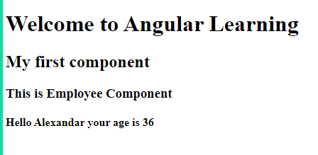

Inline template
You can have the content in the @Component itself
employee.component.html
import { Component } from '@angular/core';

@Component({
selector : "app-employee",
template : `<div>
<h3>Hi {{name}} and age: {{age}}</h3>
</div>`
})
export class EmployeeComponent {
name = "Alexandar";
age = 36;
}

Generating the component from the commands
ng g c component-name
Note: your command prompt must be in the project folder.

Project Flow:
package.json -> ng serve -> angular.json -> find the entry point file -> main.ts -> bootstrap(AppModule) -> AppModule -> bootstrap(RootComponent).

Basic building Block of angular
- Component
- Module
- Directives
- Databinding
- Pipes
- Routers
- Services.

Directives in angular
We have structural directive to work on the DOM (Document Object Model).
- To hide/show the element or content *ngIf
- To dynamically add the element *ngFor

*ngIf: Sometimes you want to show the content only if certain conditions are met, then you can use *ngIf.
*ngFor: This is used to dynamically add the elements by iterating the array.
Example:
- ng g c directive-demo
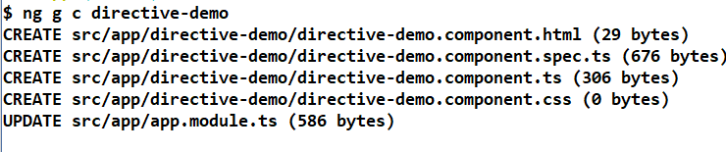

directive-demo.component.ts
import { Component, OnInit } from '@angular/core';

@Component({
selector: 'app-directive-demo',
templateUrl: './directive-demo.component.html',
styleUrls: ['./directive-demo.component.css']
})
export class DirectiveDemoComponent {
messageStatus : boolean = false;
responseStatus : boolean = true;
message = undefined;
}

directive-demo.component.html
import { Component, OnInit } from '@angular/core';

@Component({
selector: 'app-directive-demo',
templateUrl: './directive-demo.component.html',
styleUrls: ['./directive-demo.component.css']
})
export class DirectiveDemoComponent {
messageStatus : boolean = false;
responseStatus : boolean = true;
message = undefined;
}

app.component.html
<div>
<h1>Welcome to Angular Learning</h1>
<h2>{{title}}</h2>

<!-- <app-employee></app-employee>
<app-person></app-person> -->
<app-directive-demo></app-directive-demo>
</div>

Output:

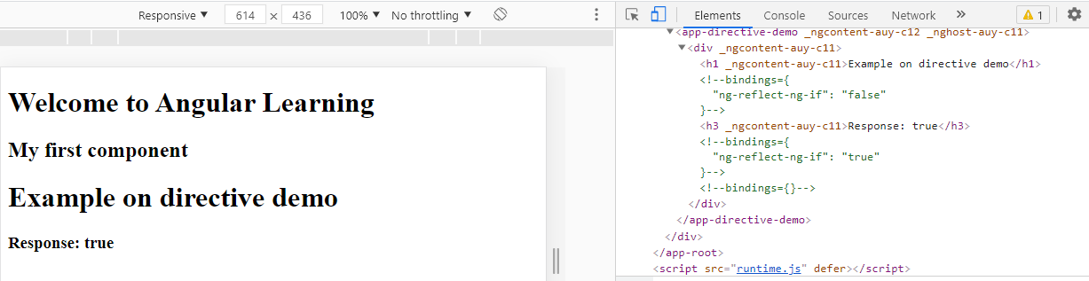

*ngFor: It is used to iterate over the array and create DOM at runtime.
directive-demo-component.ts
import { Component, OnInit } from '@angular/core';

@Component({
selector: 'app-directive-demo',
templateUrl: './directive-demo.component.html',
styleUrls: ['./directive-demo.component.css']
})
export class DirectiveDemoComponent {
messageStatus : boolean = false;
responseStatus : boolean = true;
message = undefined;
names: string[]= ["Bruce", "Alex", "David", "Charles"];
users : any = [
{"name":"Bruce","dob":"27-03-1990"},
{"name":"John","dob":"28-03-1991"}
];
}

directive-demo.component.html
<div>
<h1>Example on directive demo</h1>
<h3 *ngIf = "messageStatus">Message Status: {{messageStatus}}</h3>
<h3 *ngIf = "responseStatus">Response: {{responseStatus}}</h3>
<h3 *ngIf = "message">Message: {{message}}</h3>

<h3>Using Ng For with simple values</h3>
<ul>
<li *ngFor = "let item of names">{{item}}</li>
</ul>
<h3>Using Ng For with complex values</h3>
<ul>
<li *ngFor = "let u of users">Hello {{u.name}}, Dob is {{u.dob}}</li>
</ul>
<h3>Using NgFor to create dynamic tables</h3>
<table border = "1">
<tr>
<th>Name</th><th>Dob</th>
</tr>
<tr *ngFor = "let user of users">
<td>{{user.name}}</td>
<td>{{user.dob}}</td>
</tr>
</table>
</div>

Output:
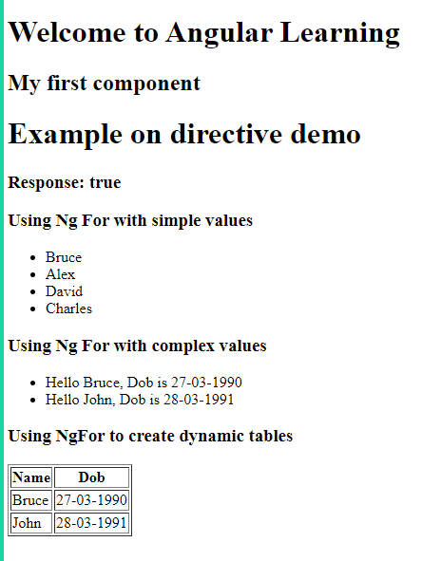

Pipes or |: It is used to transform the data, i.e., formatting the data, like uppercase, lowercase, currency, date, json and so on.
We have lot of inbuilt pipes to format the data
Like:
- uppercase
- lowercase
- date
- json
- currency
How to use it
{{outputdata | uppercase}}
{{outputdata | date}}

This is in ts file
dob = “30-03-1998”
salary = 15000;
This is in html file
{{dob | date}}
{{dob | date : ‘yyyy-MM-dd’}} 1998-03-30
{{salary | currency : ‘USD’}} $15,000
{{salary | currency : ‘INR’}} Rupee symbol.

Create a component pipe-demo
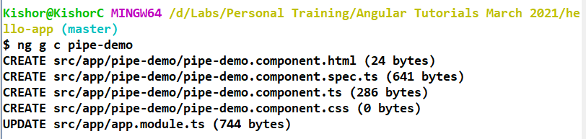
person.ts
export let singlePerson = {
"id":100, "name":"Alexandar", "dob" : "2000-03-25", "salary":15000
}

export let personArray = [
{"id":100, "name":"Alexandar", "dob" : "1998-04-20", "salary":15000},
{"id":200, "name":"Bruce", "dob" : "1999-06-25", "salary":16000},

];

Pipe-demo.component.ts
import { Component, OnInit } from '@angular/core';
import { singlePerson, personArray } from './person';
@Component({
selector: 'app-pipe-demo',
templateUrl: './pipe-demo.component.html',
styleUrls: ['./pipe-demo.component.css']
})
export class PipeDemoComponent {
person = singlePerson;
allPerson = personArray;
}

Pipe-demo.component.html
<div>
<h3>Show the single data</h3>
Hello {{person.name}}, the id is {{person.id}}, your dob is
{{person.dob}} and salary is {{person.salary}}
<hr />
<div>
Formatting string: {{person.name | uppercase}} <br />
Date : {{person.dob | date}} <br />
Date : {{person.dob | date : 'dd-MMMM-yyyy'}} <br />
Currency: {{person.salary | currency}} <br />
Currency : {{person.salary | currency : 'INR'}}
</div>

<div>
<h3>All the data using *ngFor</h3>
<ol>
<li *ngFor = "let p of allPerson">
Name: {{p.name | uppercase}}, dob is {{p.dob | date}}
</li>
</ol>
</div>

</div>

Use the pipe demo component in the root component
<div>
<h1>Welcome to Angular Learning</h1>
<h2>{{title}}</h2>

<!-- <app-employee></app-employee>
<app-person></app-person> -->
<!-- <app-directive-demo></app-directive-demo> -->
<!-- <app-demo></app-demo> -->
<app-pipe-demo></app-pipe-demo>
</div>

Custom Pipes
You can create your own pipe names which can format according to the logic
Condition:
- You must implement a PipeTransform interface
- You must use @Pipe decorator and give a name
- You must declare the pipe in the app.module.ts

Custom-pipe.ts
import { Pipe, PipeTransform } from "@angular/core";

@Pipe({
name : 'findLength'
})
export class LengthFinder implements PipeTransform {
// {{name | findLegth}}
transform(value : string) {
return value.length;
}
}

Pipe-demo.component.html
<div>
<h2>Using custom pipe</h2>
<h3>Length of name: {{person.name | findLength}}</h3>
</div>

Exercise: based on gender transform the name into either Mr. or Ms.

Databinding:
It is used to bind the data between the view-template(html) and the component class(ts)
There are mainly 4 types of databinding to share the data between view & component
- Interpolation: {{data}}: it is used to display the data, data flows from component class to view template (one-way)
- Property binding: [property]: it is used to access the DOM properties, data flows from component class to view template (one-way)
- Event binding: (eventName): it is used to handle the event, data flows from view template to the component class (one-way), in angular you have all the events name without the suffix ‘on’
HTML events | Angular events
Onclick | (click)
OnInput | (input)
(onChange) | (change)

- Two way data binding: [(ngModel)]: it is used to bind the data in both directions, here the changes done in the view is reflected to the component and vice versa

There are 2 types of databinding where data sharing happens between the components i.e., from one component to another component.
- @Input()
- @Output()

Data-binding-demo.component.html
<div>
<h2>Databinding demo</h2>
<hr />
<h3>Interpolation</h3>
Name is: {{username}}
<hr />
<h3>Property binding</h3>
<input type = "button" value = "ClickHere" [disabled] = "isDisabled">
<br />
Value of isDisabled: {{isDisabled}}
<br />
<input type = "button" value = "Change" (click) = "handleClick()">
</div>

Data-binding-demo.component.ts
import { Component, OnInit } from '@angular/core';

@Component({
selector: 'app-data-binding-demo',
templateUrl: './data-binding-demo.component.html',
styleUrls: ['./data-binding-demo.component.css']
})
export class DataBindingDemoComponent {

username = "Bruce";
isDisabled = false;

handleClick() {
this.isDisabled = !this.isDisabled;
}

}

Two way databinding:
The data sharing happens between view to component & component to view both, two way databinding is achieved using [(ngModel)] where you will assign the property of the component to [(ngModel)] in the view
<input type = “text” [(ngModel)] = “property”>.
ngModel property is part of FormsModule which needs to be added in the AppModule imports section.

Data-binding-demo.component.ts
import { Component, OnInit } from '@angular/core';

@Component({
selector: 'app-data-binding-demo',
templateUrl: './data-binding-demo.component.html',
styleUrls: ['./data-binding-demo.component.css']
})
export class DataBindingDemoComponent {

username = "Bruce";
isDisabled = false;
emailId = "bruce@gmail.com";

handleClick() {
this.isDisabled = !this.isDisabled;
}

}

Data-binding.demo.component.html
<div>
<h2>Databinding demo</h2>
<hr />
<h3>Interpolation</h3>
Name is: {{username}}
<hr />
<h3>Property binding</h3>
<input type = "button" value = "ClickHere" [disabled] = "isDisabled">
<br />
Value of isDisabled: {{isDisabled}}
<br />
<input type = "button" value = "Change" (click) = "handleClick()">
<h3>Two way databinding</h3>
<input type = "text" [(ngModel)] = "emailId">
<input type = "text" [(ngModel)] = "emailId">
</div>

[(ngModel)] binds the data between view to component & vice versa, but ngModel is a property of FormsModule hence you must import it in the AppModule imports section.
app.module.ts
import { BrowserModule } from '@angular/platform-browser';
import { NgModule } from '@angular/core';

import { AppComponent } from './app.component';
import { EmployeeComponent } from './employee/employee.component';
import { PersonComponent } from './person/person.component';
import { DirectiveDemoComponent } from './directive-demo/directive-demo.component';
import { DemoComponent } from './demo/demo.component';
import { PipeDemoComponent } from './pipe-demo/pipe-demo.component'
import { LengthFinder } from './pipe-demo/custom-pipe';
import { DataBindingDemoComponent } from './data-binding-demo/data-binding-demo.component';
import { FormsModule } from '@angular/forms';

@NgModule({
declarations: [
AppComponent, EmployeeComponent, PersonComponent, DirectiveDemoComponent, DemoComponent, PipeDemoComponent,
LengthFinder,
DataBindingDemoComponent
],
imports: [
BrowserModule, FormsModule
],
providers: [],
bootstrap: [AppComponent]
})
export class AppModule { }

Another type of binding is class & style binding this is used to apply styles to the view
Class binding is done with the property whose value will be either true/false.
Data-binding.demo.component.html

<div>
<h3 [class.blueColor] = "isDisabled">CSS Class Binding</h3>
</div>

Data-binding.demo.component.css
.blueColor {
color : blue;
}

Data-binding-demo.component.ts
import { Component, OnInit } from '@angular/core';

@Component({
selector: 'app-data-binding-demo',
templateUrl: './data-binding-demo.component.html',
styleUrls: ['./data-binding-demo.component.css']
})
export class DataBindingDemoComponent {

username = "Bruce";
isDisabled = false;
emailId = "bruce@gmail.com";

handleClick() {
this.isDisabled = !this.isDisabled;
}

}

@Input & @Output binding
This is used to share data between the components, like from one component to another component like parent to child and vice versa.
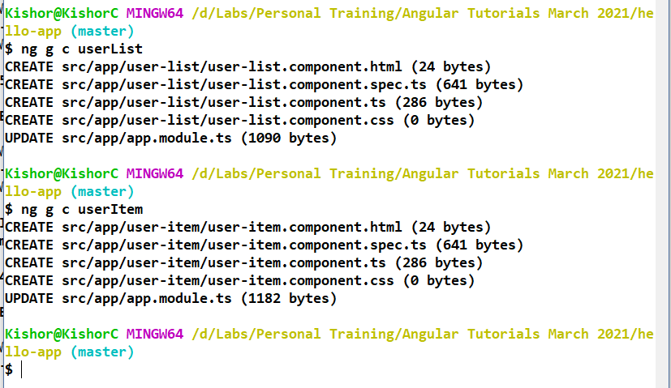
Here userItem can be added to the userList so that userList acts like parent & userItem acts like child, later you can add userList to the root component.

@Input() is a decorator used to share the data between parent to child, here @Input() is written in the child component variable(property) and that property is bind in the child component selector.

User-list.component.ts
import { Component, OnInit } from '@angular/core';

@Component({
selector: 'app-user-list',
templateUrl: './user-list.component.html',
styleUrls: ['./user-list.component.css']
})
export class UserListComponent {
firstname = "Bruce";
namesArray = ["Sachin","Sourav","Dhoni","Zaheer"];
}

User-list.component.html
<div>
<h3>This is user list component</h3>
<h4>Firstname in parent: {{firstname}}</h4>
<hr />
<div style = "text-align: center;">
<app-user-item></app-user-item>
</div>
<div style = "text-align: center;">
<app-user-item [username] = "firstname"></app-user-item>
</div>
<div *ngFor = "let name of namesArray">
<app-user-item [username] = "name"></app-user-item>
</div>

</div>

User-item.component.ts
import { Component, Input, OnInit } from '@angular/core';

@Component({
selector: 'app-user-item',
templateUrl: './user-item.component.html',
styleUrls: ['./user-item.component.css']
})
export class UserItemComponent {
@Input()
username = "Alex";
}

User-item.component.html
<div>
<h3>This is user item component</h3>
<h4>Username in child: {{username}}</h4>
</div>

Output:
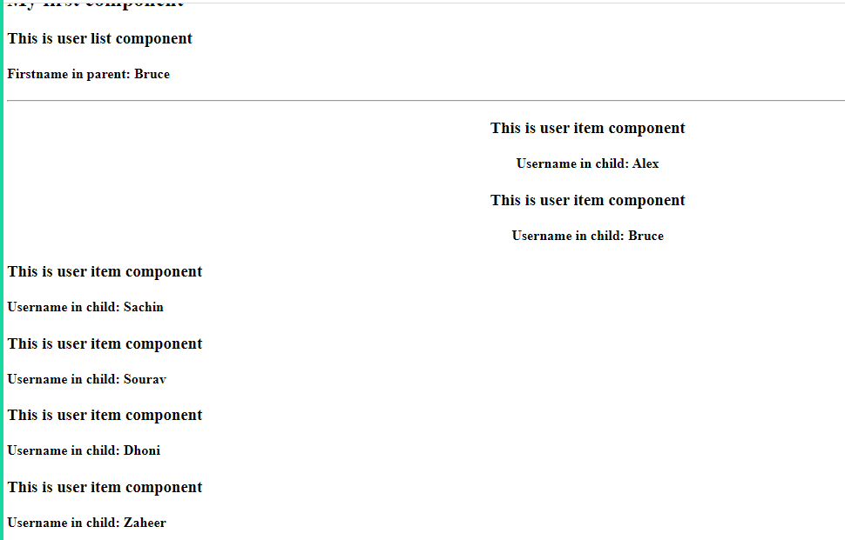

@Input: is to share the data from parent to child, here @Input() is used as a property binding i.e., [child] = “parent”
Note: you can pass even complex data also
@Output: is to share the data from child to parent, here @Output() is used as an event binding i.e., (child) = “parent = $event”.
Note: whenever you want child component to share the data to parent component you must use EventEmitter object, because it generates the event object ($event) which will have the data of the child which is emitted and can be assigned to the parent property

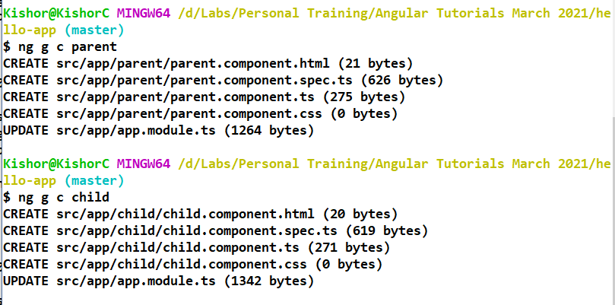

Parent.component.ts
import { Component, OnInit } from '@angular/core';

@Component({
selector: 'app-parent',
templateUrl: './parent.component.html',
styleUrls: ['./parent.component.css']
})
export class ParentComponent {
parentData = "This is parent data which flows to child";
childCounter = 0;
}

Parent.component.html
<div>
<h2>Parent Component</h2>
<h3>Counter inside parent : {{childCounter}}</h3>
<hr />
<app-child [childData] = "parentData"
(counterEvent) = "childCounter = $event"></app-child>
<!--
Here counterEvent generates the event which is the counter value
of child component which is assigned to the counter value of
parent component through $event
-->
</div>

Child.component.ts
import { Component, EventEmitter, Input, OnInit, Output } from '@angular/core';

@Component({
selector: 'app-child',
templateUrl: './child.component.html',
styleUrls: ['./child.component.css']
})
export class ChildComponent {

@Input()
childData = "This is child data";

counter = 0; // need to be sent to parent

// here EventEmitter is emitting only the number
@Output()
counterEvent : EventEmitter<number> = new EventEmitter<number>();

handleClick() {
this.counter++;
this.counterEvent.emit(this.counter); // emits the counter value
}
}

Child.component.html
<div>
<h2>Child Component</h2>
{{childData}} and Counter: {{counter}}
<br />
<button (click) = "handleClick()">Click Here</button>
</div>

Output:
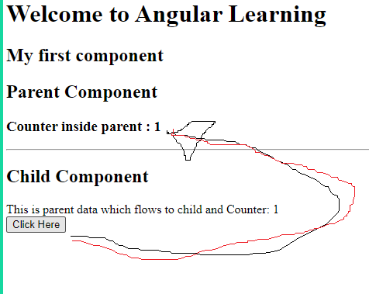

Adding bootstrap.js to the angular
There are 2 ways where you can add bootstrap.js to the angular
- Adding the CDN <link> tag in the index.html
- Downloading the bootstrap into the angular application.

Add the <link> in index.html
<!-- CSS only -->
<link href="https://cdn.jsdelivr.net/npm/bootstrap@5.0.0-beta3/dist/css/bootstrap.min.css" rel="stylesheet" integrity="sha384-eOJMYsd53ii+scO/bJGFsiCZc+5NDVN2yr8+0RDqr0Ql0h+rP48ckxlpbzKgwra6" crossorigin="anonymous">

But the above procedure works only if you have the internet connection, since we can’t rely on the remote service of bootstrap css to be used in angular we can manually download into the angular application.
How to download the bootstrap into the angular application
- Use npm install bootstrap jquery –-save, this downloads the libraries inside node_modules
- Add the location of bootstrap & jquery in the angular.json file

Downloading the bootstrap & jquery
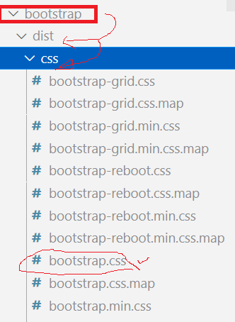

Updating the angular.json
